CALCULATE TRIP COST PROJECT

Software Requirements Specification

|  |  |  |  |
| --- | --- | --- | --- |
|  | Prepared By | Reviewed By | Approved By |
| Name | The Runtime-Terror | Devathilagai |  |
| Role | PAT | Batch Trainer |  |

Table of Contents

1. Introduction 3

1.1 Intended Audience 3

1.2 Project Scope 3

2. Overall Description 3

2.1. Operating Environment 3

3. Requirements 4

3.1 Functional Requirements 4

3.1.1 Req001 Holiday Homes 4

3.1.2 Req002 Cruise Details 5

# Introduction

Tripadvisor is an online travel booking website. We are taking and testing two functionalities of that website (i.e.) listing the results of trip cost and reading the details of a particular cruise ship.

## Intended Audience

* 1. Business Unit (BU) SME
  2. Academy coach
  3. Technical Trainer

## Project Scope

This document defines at a functional level the business activities that are encompassed by the system and the rules that apply to them. It also encompasses some of the key high- and low-level technical requirements of the system.

It draws heavily on both proposed Framework and Business Rules and the Technical Architecture documents. The scope of the detailed analysis project phase specifies that this document will include:

* Classification of requirements according to their functional areas.
* A description of each process in the system, including their inputs, outputs, and data transformation rules.

# Overall Description

### 2.1. Operating Environment

* Windows operating system
* Web application

# Requirements

This part of the requirements document serves to present the results of trip cost and reading the details of a particular cruise ship.

## Functional Requirements

### Req001 Holiday Homes

**Req001a-** The user enters the text ‘Nairobi’ in “Where to?” search box and selects ‘Nairobi from the auto suggestion list box.

**Req001b-** The user clicks on “Holiday Homes” tab.

**Req001c-** The user puts necessary details like “Check-in”, ”Check-out” and ”Guests”

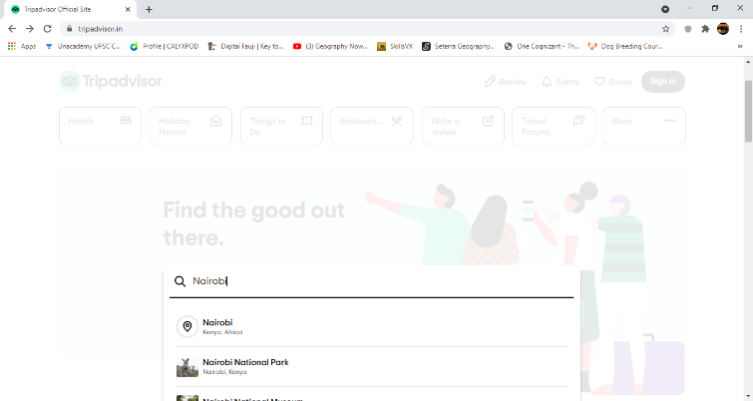**Req001d-** The user applies necessary filter like ‘Traveler Ratings’ under “sort by” and ‘Elevator/Lift access’ under Amenities.

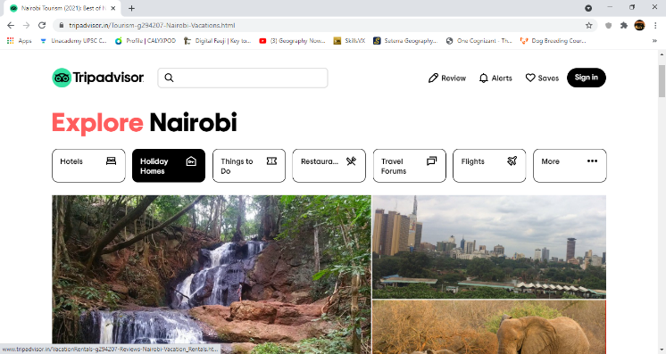

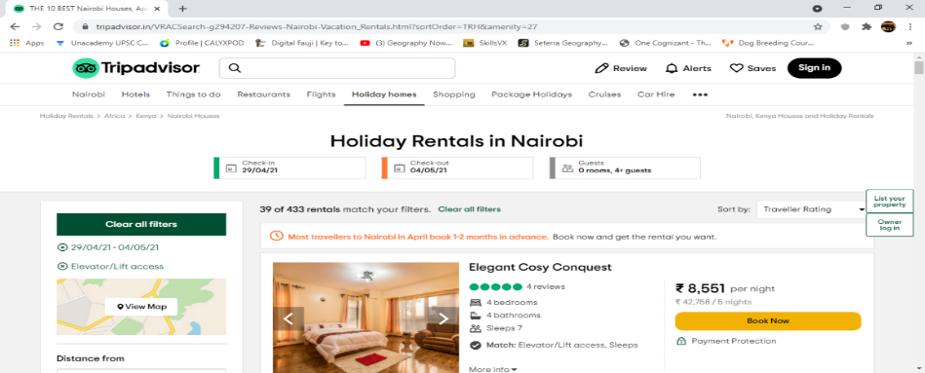

### 3.1.2 Req002 Cruise Details

**Req002a-** The user clicks on “cruises”

**Req002b-** The user clicks on “Cruise line” dropdown menu and selects an option.

**Req002c-** The user clicks on “Cruise ship” dropdown menu and selects an option.

**Req002d-** The user clicks on [Search] button.

